DBT SELF-LEARNING
GROUP BY PROBLEM
QUESTION 1
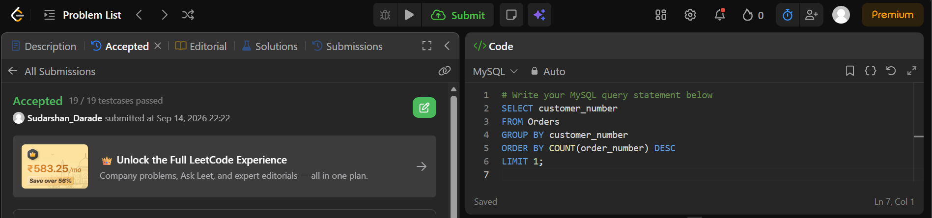

QUESTION 2
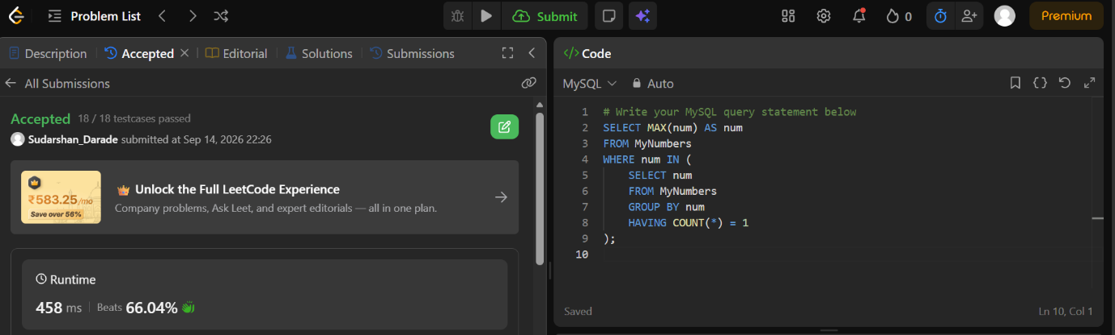

QUESTION 3
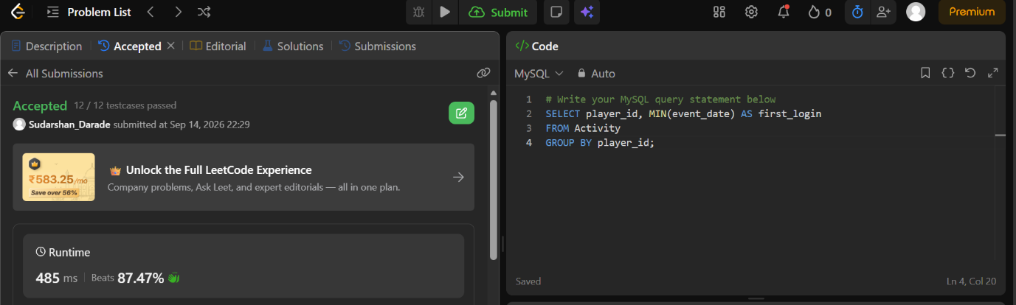

QUESTION 4
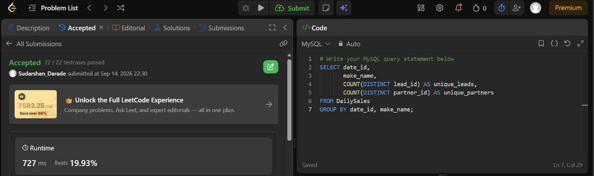

QUESTION 5
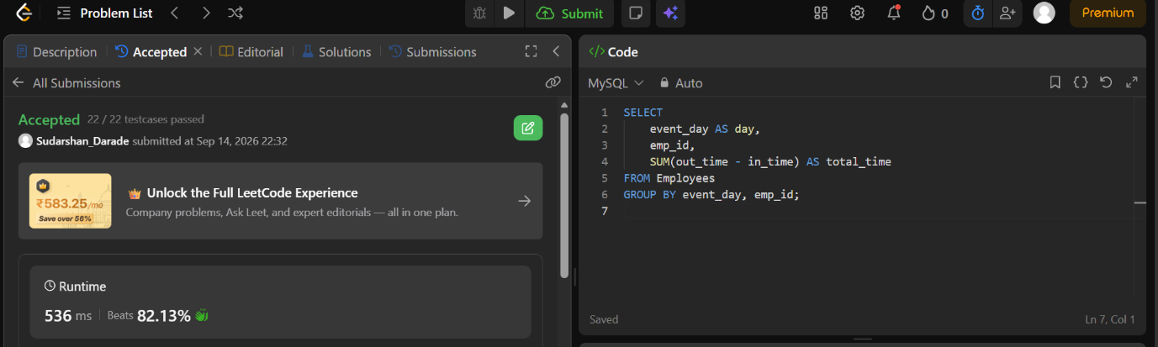

QUESTION 6
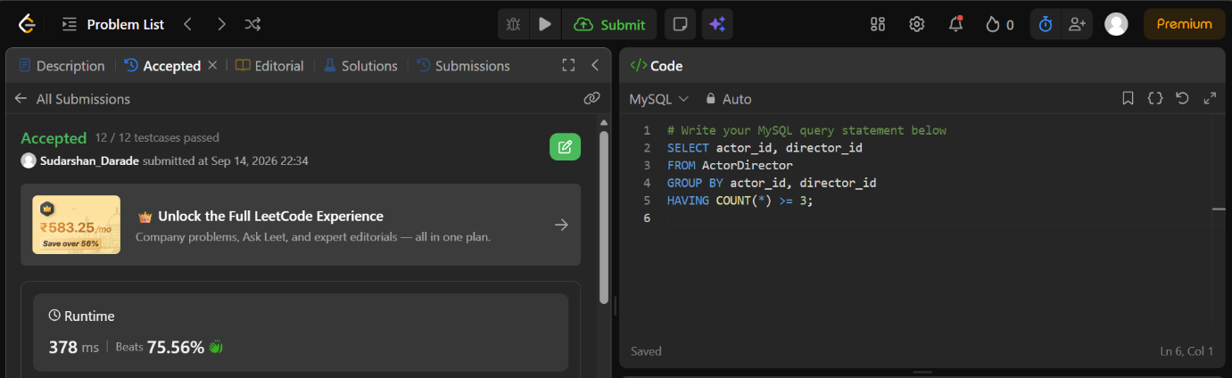

QUESTION 7
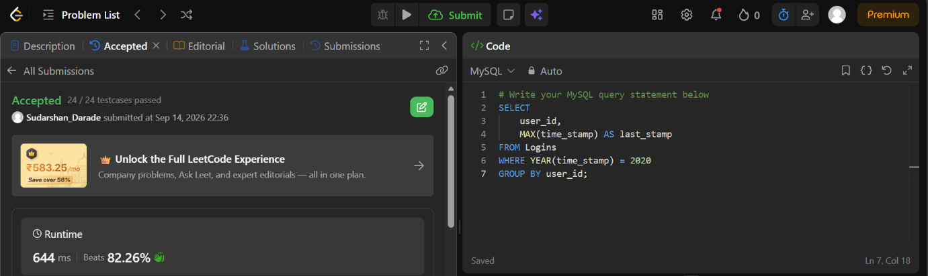

QUESTION 8
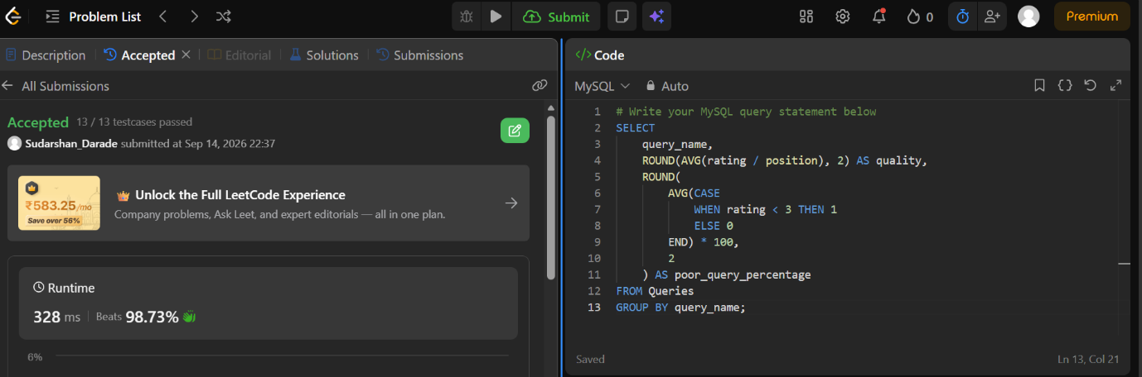

QUESTION 9
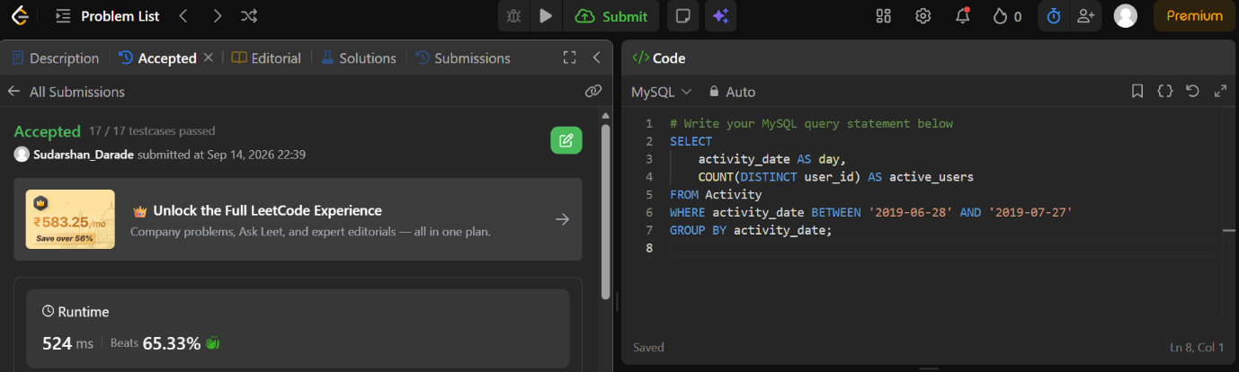

QUESTION 10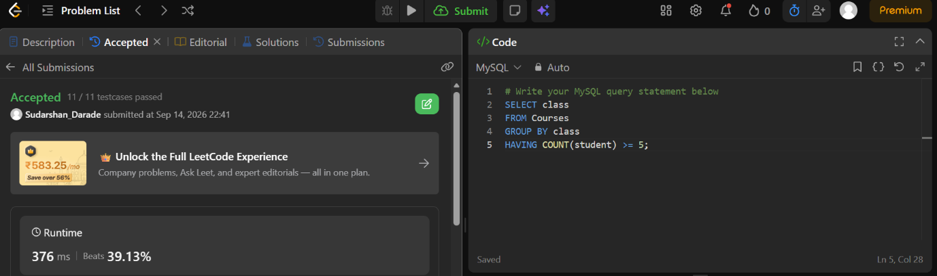

JOINS PROBLEM
QUESTION 1
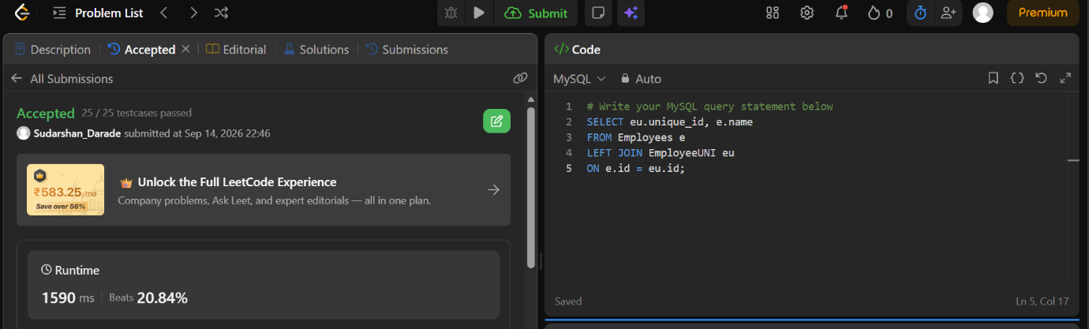

QUESTION 2
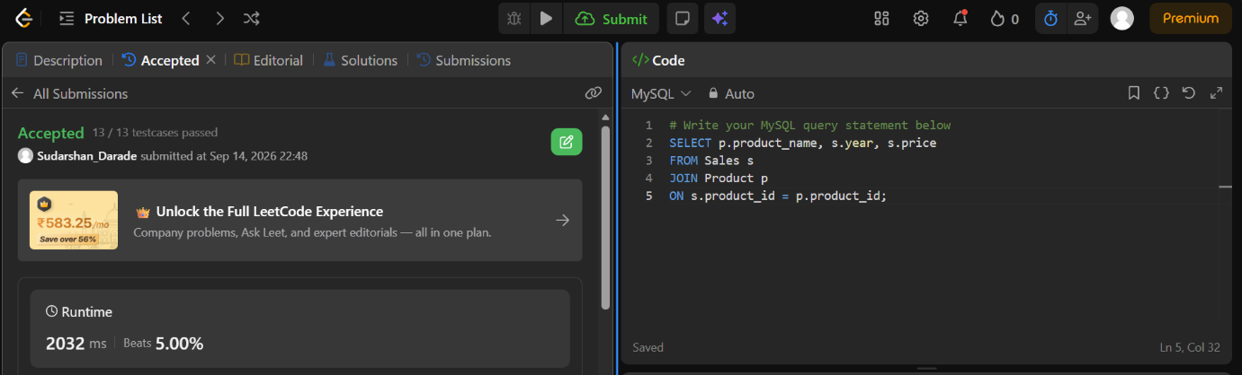

QUESTION 3
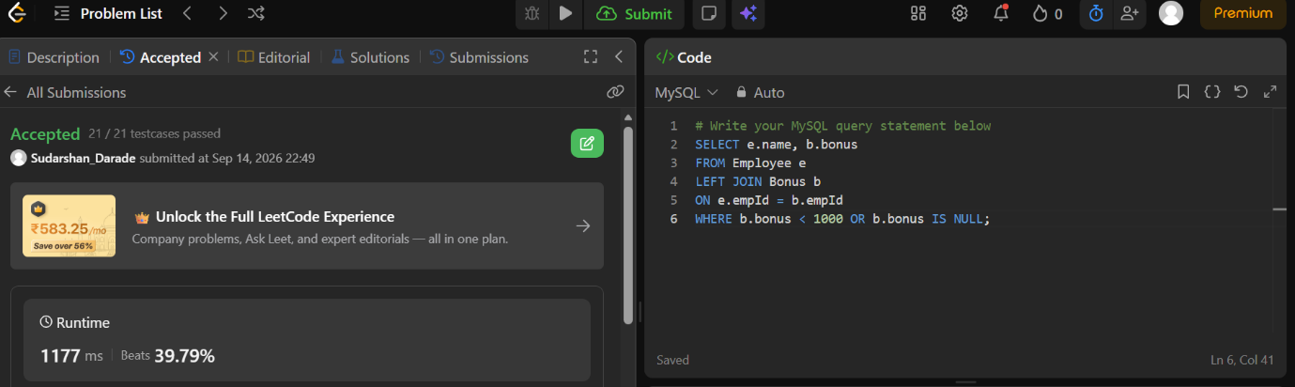

QUESTION 4
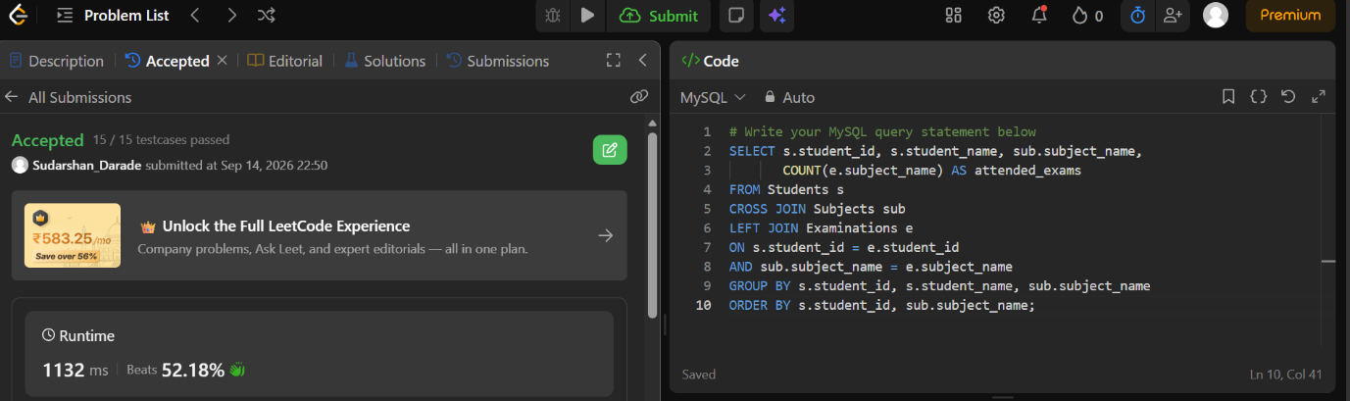

QUESTION 5
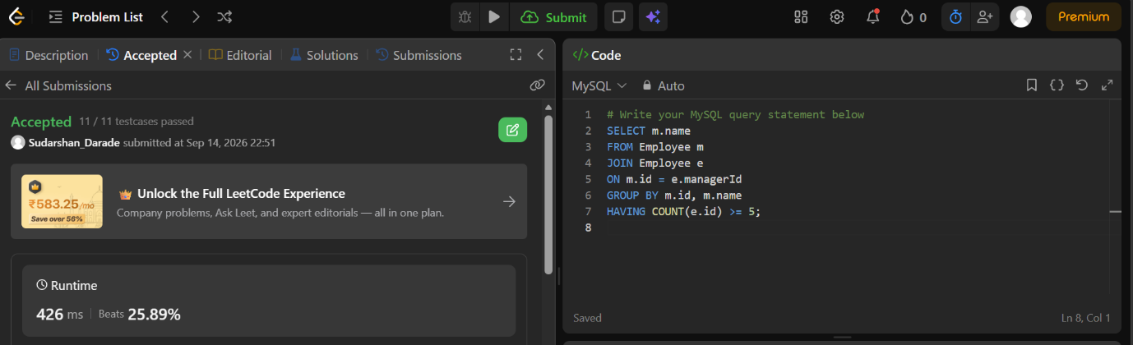

QUESTION 8

Question 9
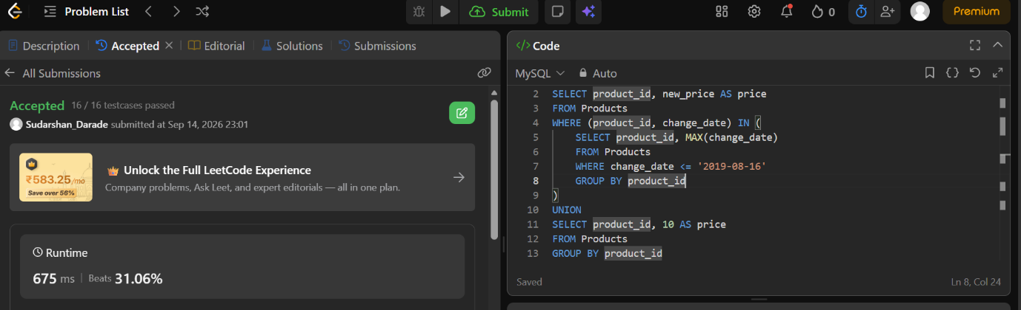

SUBQUERY PROBLEM
QUESTION 1
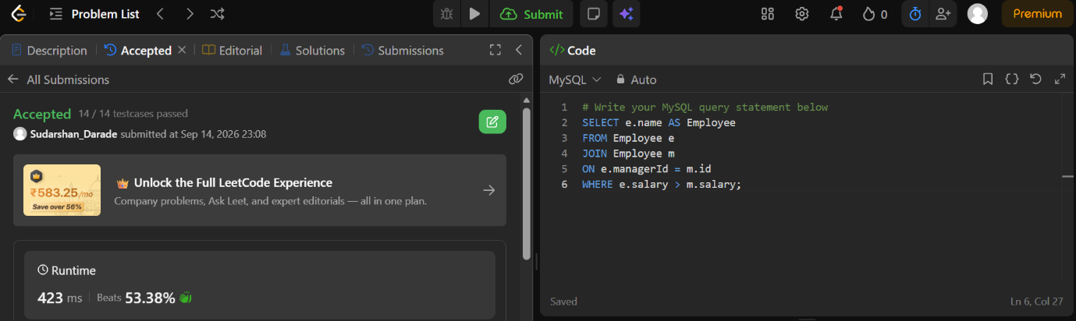

QUESTION 2
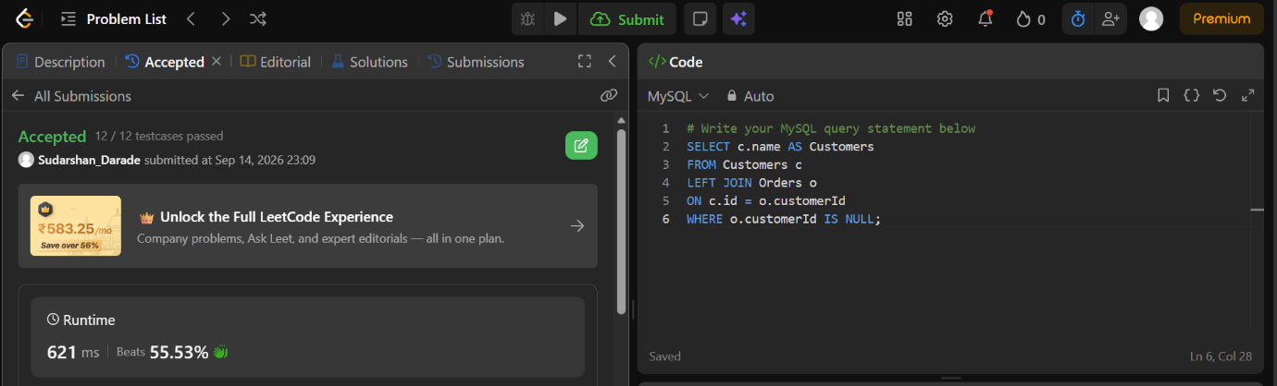

QUESTION 3
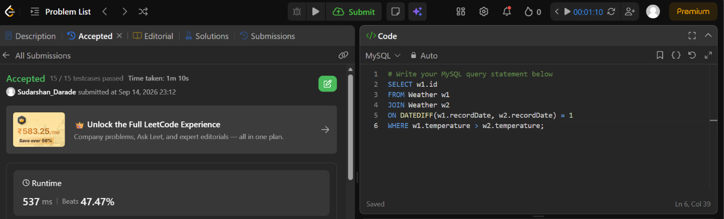

QUESTION 4
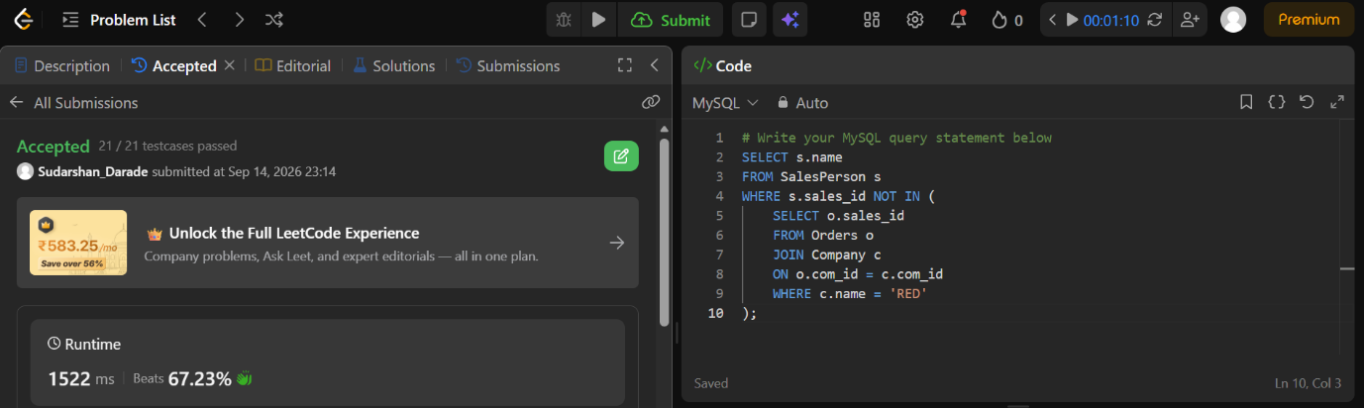

QUESTION 5
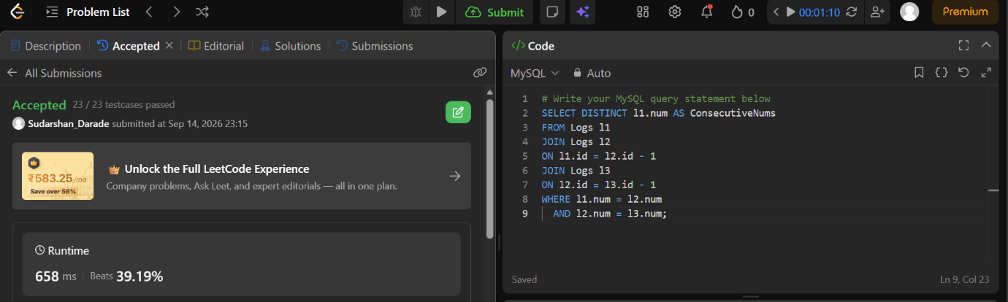

QUESTION 6
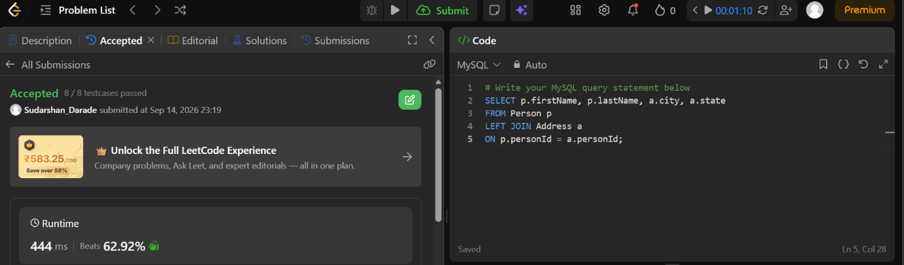

QUESTION 7
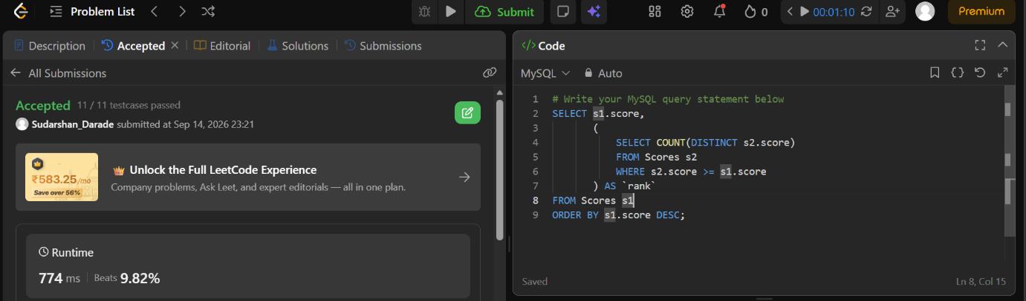

QUESTION 9
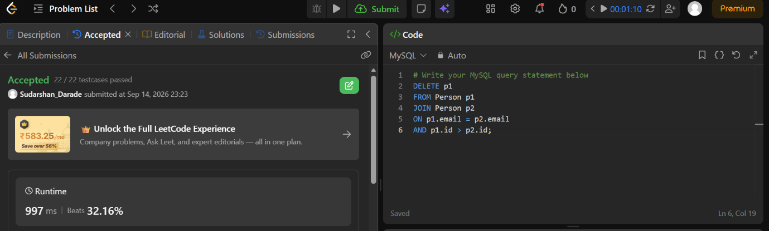

QUESTION 10
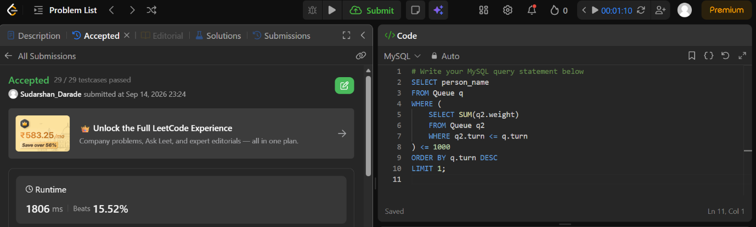

QUESTION 11
